Ian McPherson

Comp 3220

Power

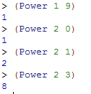

FindMaxMin

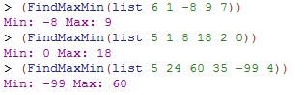

Reverse

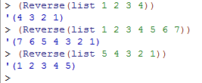

Union

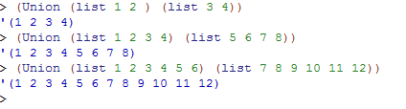

Quicksort

